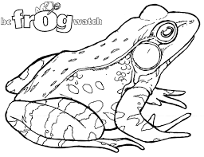

Frog Quiz!!
See how many of these questions you can answer-hint – listen to the frog talk with the Waterwatch Coordinator.

- Name one local Melbourne frog
_______________________________________________
- How many frog species are there in the world
________________________________________________
- What do frogs eat?
________________________________________________
- Draw or name the 4 stages in the frog life cycle

1._________________
2._________________
3._________________
4._________________

- Does the male or female frog call? Why?

- Name 3 items that can make a creek, wetland or lake polluted
1._________________
2._________________
3._________________

7. How can frog let us know that a lake, wetland, creek or river is polluted? Hint…what’s special about a frog’s skin?
________________________________________________

- Polluted, dirty water isn’t the only thing hurting frogs around the world. What are other things that might damage frog populations?

________________________________________________
- How can you tell where a frog lives just by looking at its feet? (Hint: - look at the differences between these two frog’s legs and feet.)
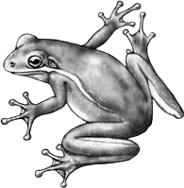
www.natureworkspress.com
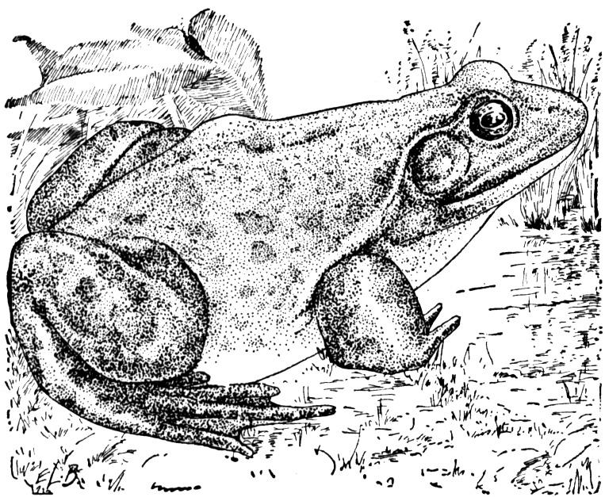
www.shs2.westport.k12.ct.us
________________________________________________

